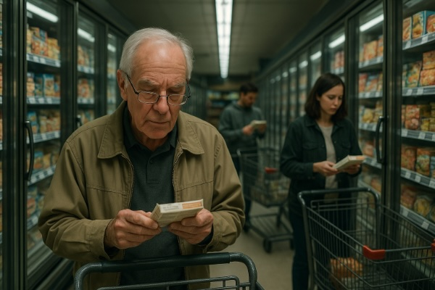
Tired of trying to read tiny ingredients lists and nutrition panels? Use FoodScreener!

FoodScreener
Instantly scan and compare foods to your diet goals. FoodScreener helps you find healthier choices in seconds.
Available now on the App Store for iPhone: FoodScreener for iPhone
New! – Available for Android phones as well: FoodScreener for Android

Your Food Preferences, Your Choice
FoodScreener helps you make smarter grocery choices instantly. Scan barcodes to see nutrition facts, ingredient warnings, and allergens in seconds—even offline. Compare similar-looking products side-by-side to spot hidden sugar, sodium, or additives. Perfect for families with allergies, health-conscious shoppers, or anyone who wants to take control of their diet in the store aisle.
Unique in barcode scanning from 2" to 20' for phones with multiple lenses. The only food scanner app that lets you set your food preferences. Others have rigid criteria or preferences set by the app developer. We don't impose our food preferences on you. Also the only food scanner that lets you download a compressed food database for offline scanning -- many stores have poor cell service or spotty wifi.
FoodScreener Features:
- Barcode scanning for nutrition info
- Compare similar products
- Personalized alerts for allergens/diet
- Offline database for stores with poor data service
- Multiple language support (EN, ES, FR, DE)
- Clean, intuitive design for quick scanning
Multilingual, v1 has English, Spanish, French, and German modes. Supports light and dark modes. Freemium pricing, 20 scans in trial period. No ads, tracking, or subscriptions. Paying for app allows syncing your preferences to all your phones (v1 is iOS, with Android coming soon.) Beta testers get unlimited use.

Our Story:
We needed help to read tiny ingredient lists in crowded, dimly-lit stores to find time-saving prepared food products that didn't have unacceptable ingredients and fit our diet. Avoiding some ingredients like seed oils, excess sugar, and artificial colors was hard. We are fit in our 60s and exercise and clean eating are why we are aging more slowly -- but we had kids to feed and limited time to cook using fresh, natural ingredients. Buying the *right* packaged food products saves time and maintains our clean eating.

Interesting Side Story:
Our main programmer retired 20 years ago but found the new AI assistants made it much less tedious, so he was able to program the app in an unfamiliar language and catch up with all the modern tools available in a few months. This part of the story might interest general readers. I’ll include a Q&A for this human interest side story.

FoodScreener Neutrality
As developers, we wanted this tool to be useful no matter what your dietary preferences are. Modern processed foods are often sweetened and use lower-cost ingredients that might or might not be unhealthy, with overconsumption leading to metabolic syndrome. The default preferences (before user changes them) disfavor high sugar and low protein entrees. But setting the preferences changes FoodScreener’s evaluations. For example, we take no position on the current anti-seed-oils ideas, but if you want to avoid them, just set the “No Seed Oils” preference to 100% and you will be alerted to any of the seed oil suspects. If you really hate corn oil and only corn oil, you can set that preference alone.

Diet Preferences
We’re not especially anti-meat, but we understand many people are. A vegetarian or vegan diet is thought by many to be healthier and more ethical, so FoodScreener can be helpful in screening out animal products as well as assisting in choosing foods that contain more and higher quality protein to make up for the lack of meat, which is important to maintaining good health. Similarly, if you believe in keto or paleo diets, FoodScreener will steer you to more suitable products if you set that diet preference.

Contact Info:
Email: support@foodscreener.org
Website: https://foodscreener.org

FoodScreener Icon
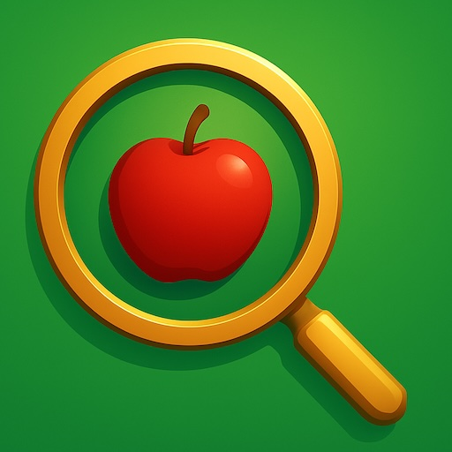
App Icon

How to Use FoodScreener:

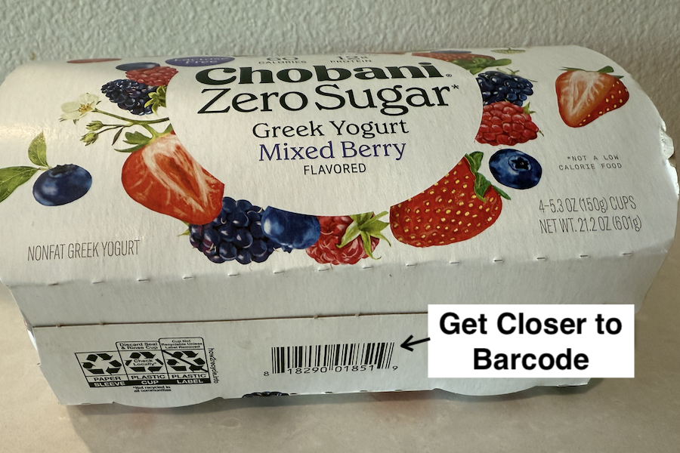
First, touch the Scan button and get barcode in view. You can scan as close as 2” and as far as 20’ using zoom if your phone has an advanced multicamera system. When the barcode scan finishes, you’ll get visual and haptic feedback.
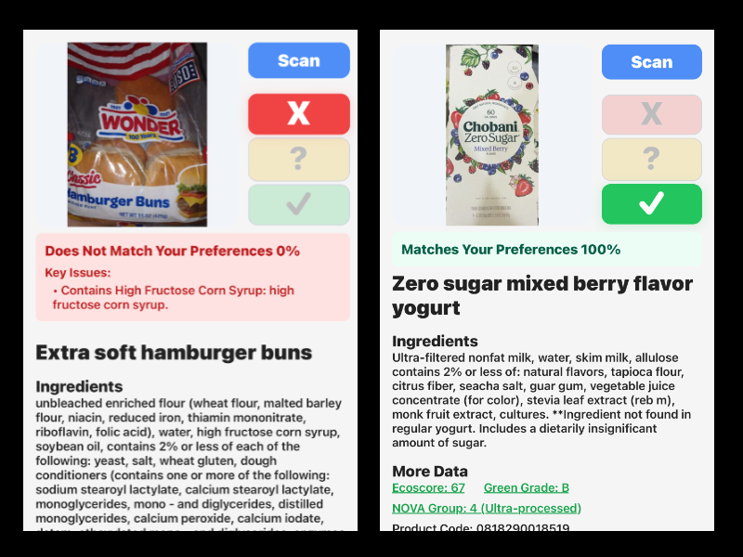
Results are fast if the product is in the on-app database, but can take a second if not (and can be even slower with the bad cell service or spotty wifi in stores.) The Product screen will show you ingredients, nutrition, and the app’s rating of the product based on your chosen preferences.
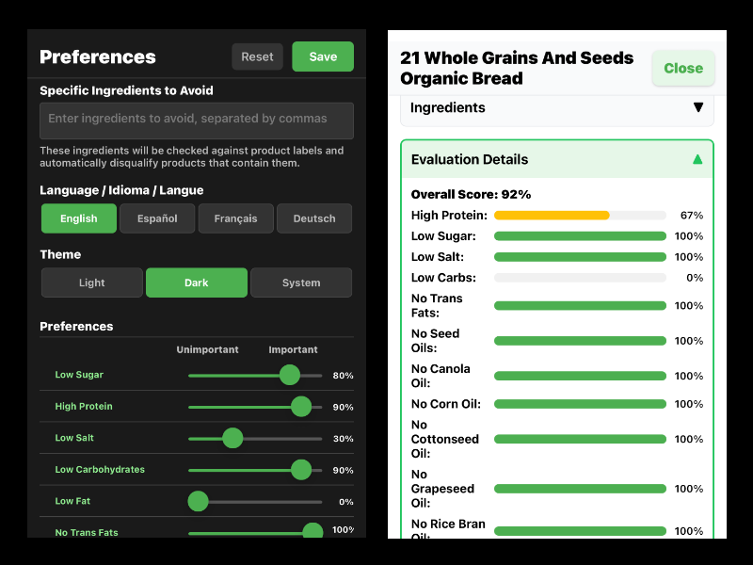
Go to the Preferences tab to set up your dietary restrictions, allergies, and food values. Slide each option to indicate its importance to you: 100% if the pref is critical, 0% if you don't care, in between if you care a little. The algorithm will match your prefs against product data and indicate STOP-CAUTION-GO. While FoodScreener is a reliable source, we urge anyone with life-threatening allergies to check the ingredients list carefully and avoid the product if there is any doubt.
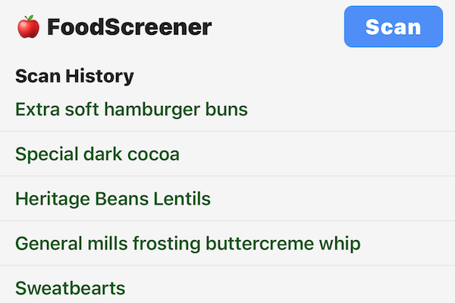
The Home screen shows the history of items you’ve scanned. Touch an item and its product screen will be re-displayed so you can compare and contrast as you shop.
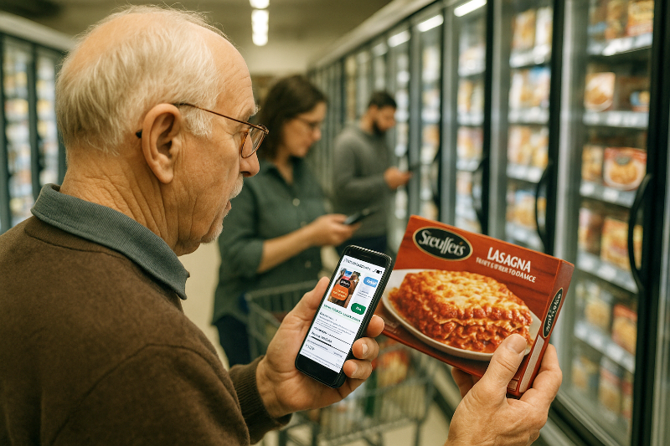
Now you can make informed food choices based on your personal preferences. Sign up for an account at About->Login->Signup to sync your prefs to our secure cloud storage. See our Privacy Policy under About: Your personal data will not be sold, and we will only contact you via email with critical product updates. Happy scanning!

Legal Notes:
Disclaimer: FoodScreener is an independent mobile application designed for consumers to scan food barcodes and evaluate products based on dietary preferences. It is not affiliated with, endorsed by, or related to Bruker BioSpin GmbH or its laboratory product, FOODSCREENER®, which is used for scientific food analysis.

